Radiocarbon dating
ANSTO scientists use radiocarbon dating to determine the age of ancient artefacts and to study climate change.
This dating method works by measuring the ratio of different isotopes of carbon in a sample using a particle accelerator.
There are three main isotopes of carbon on earth.
- Carbon-12 isotope (99% of all carbon on earth)
- Carbon-13 (almost 1% of all carbon on earth)
- Carbon-14 (trace amounts only)
Carbon-12 and carbon-13 are both stable isotopes, but carbon-14 is unstable and is radioactive.
a) Use the information above and the words provided to fill in the blanks:

seven (7) trace stable most common radioactive eight (8) nucleus six (6)
Carbon-12 is the ________ __________ carbon isotope. It is __________ and contains 6 protons and 6 neutrons in its ____________. Carbon-13 makes up almost 1% of all carbon on earth. It is also stable and contains 6 protons and ______ neutrons in its nucleus. Carbon-14 is found in only ___________ amounts. It is unstable and ___________________, and its nucleus contains ______ protons and _____ neutrons.
b) Draw an atom of carbon-12 and an atom of carbon-14 using the key supplied. The atoms should show the number of protons, neutrons and electrons in each.

Radiocarbon dating (cont.)
Living things contain carbon-14 and carbon-12 in a ratio that is the same as in the atmosphere at the time. When the organism dies, the ratio of carbon-14 to carbon-12 decreases, as carbon-14 decays and is no longer incorporated into the organism.
Using carbon dating, scientists can calculate how much carbon-14 decay has occurred by measuring the ratio of carbon-14 to all carbon atoms in the sample. The extent of carbon-14 decay will reveal the age of the sample. The half-life of carbon-14 is 5730 years and a graph of carbon-14 is below:
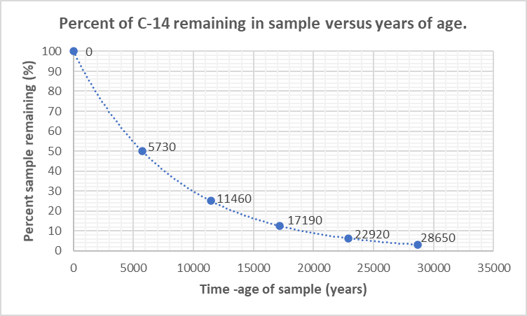
For example, a scientist calculates that an artefact contains only 50% of the original amount of carbon-14 it contained when it died. The scientist would use a graph like the one above to calculate that the artefact is approximately 5730 years old.

8. Radiocarbon dating (cont.)
Use the graph of carbon-14 decay on the previous page to solve these real-life science puzzles:
- In 1991, hikers in Northern Italy found the perfectly preserved frozen body of a prehistoric man. Scientists named him Ötzi. Samples of his bones, hair, boots and clothes were carbon dated and revealed that Ötzi lived almost 5500 years ago.
What percentage of the original carbon-14 in Ötzi’s body was remaining in 1991?
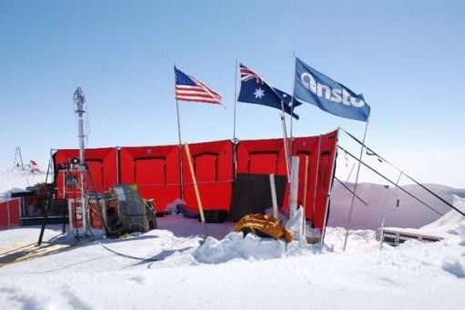
- Climate scientists, including Dr Andrew Smith at ANSTO, drill deep into Antarctic ice to find out more about the gases in our atmosphere thousands of years ago. As layers of snow and ice form year after year, air bubbles become trapped deep in the ice and serve as a frozen historical record of the gases in our atmosphere over time.
The eldest ice core from Antarctica so far was 3200m deep. Scientists dated the gases in the air bubbles at the bottom of this ice core and found that only 29% of the original carbon-14 remained.
How long ago were these air bubbles trapped in the ice? About 10,000 years ago
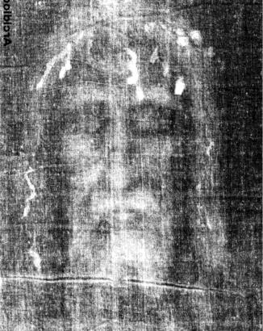
- The authenticity of the Shroud of Turin had long been debated. The shroud is said to be a piece of cloth that was used to wrap the body of Jesus after he was crucified. In 1988, scientists received permission from the Vatican to remove small samples for carbon dating. Three different laboratories around the world analysed the samples. All three laboratories came to a similar conclusion: The shroud had 92% of its carbon- 14 atoms remaining.
What is the approximate date of origin of the Shroud of Turin?
(Note: Despite these and other scientific investigations, the origin and date of the Shroud of Turin remains a subject of controversy.)

- Carbon dating is most useful for determining the age of objects up to about 50,000 years old.
Why is carbon dating less accurate for objects older than this?
The half-life of carbon-14 is 5,730 years. The percentage of carbon-14 remaining in artefacts older

